Test Plan:
- Requirement: Goliath shall be completed by Wednesday, December 14, 2016 [3].
  - Method:
    - Inspection
  - Materials:
    - Project Libre
    - Burn down
    - Excel
  - Procedures:
    - Record number of task assigned on Project Libre to the table 7 below.
    - Record the number of task completed.
    - Calculate the percentage of task done.
Percentage of task done = (Number of Completed Task) / (Total Number of Task)
Table 7
Number of total Task | 73
Number of Task completed | 73
Percentage of task done | 100%

Burn Down:
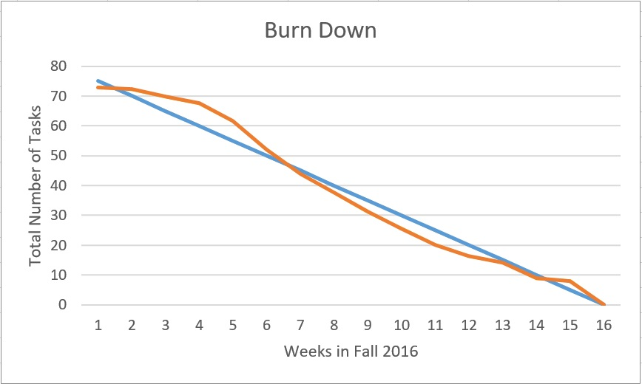
Number of Task Per Week:

  - Conclusion:
    - Criteria to Pass: 100% of the task are completed by December 14, 2016.
Looking at Project Libre we had 73 task. All these tasks were inserted into Excel to determine the percentage done for each week. All tasks were completed as shown in the Burn Down and number of tasks per week in the reality done row. Therefore, we have 100% task done.

- Requirement: The budget shall not exceed $150 [4].
  - Method:
    - Inspection
  - Materials:
    - Receipts
    - Excel
  - Procedures:
    - Gather all recipes together and fill out table 1.

Table 1
# | Product Part | Price
1 | 3Dot Board | $0.00
2 | Android Phone | $0.00
3 | Battery | $0.00
4 | Tracks/Wheels/Rod | $6.85
5 | PCB Board | $8.55
6 | PCB Parts 1 | $24.32
7 | PCB Parts 2 | $12.09
8 | PCB Stencil | $11.83
9 | Sensors | $87.20
10 | 3D Print | $25.00
11 | Motor | $43.47
Total |  | $228.30

  - Conclusion:
    - Criteria to Pass: Total sum of receipts of parts used is below $150.
    - Receipts

Our budget for Goliath was $150 but our totals spendings was $228.30. We went over because of the extra motors we bought and we were charged for 3D printing. In conclusion we failed to meet the criteria to pass.

- Requirement: All parts being 3D printed shall be printed under 6 hours with no single print under 2 hours. [5]
  - Method:
    - Analysis
    - Demonstration
  - Materials:
    - Makerbot
    - 3D models of Goliath parts on Solidwork
  - Procedures:
    - Upload Solidwork files onto Makerbot.
    - Fill out the correct settings for Goliath (Quality, Layer Height, Material, Infil, Number of Shells)
    - Examine print time of analysis.
    - When printing the final print, time the how long the total print took place

Makerbot Analysis:
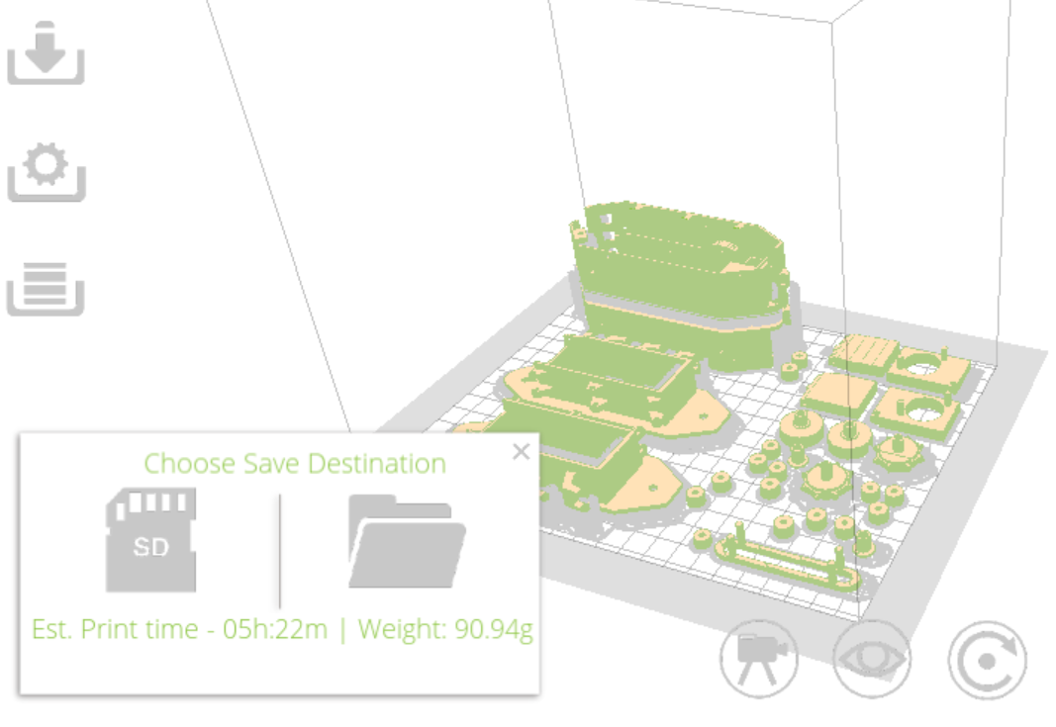

Total Print time for Final Print: 5 hours 22 minutes = 322 minutes
  - Conclusion:
    - Criteria to Pass: Sum of print time is under 6 hours or 360 minutes with each part under 2 hours.
As our print analysis predicted by our Makerbot prediction our total print time is 322 minutes which is under 6 hours. Therefore, Goliath passed the print time requirement of 6 hours.

- Requirement: Goliath shall follow the Biped at a fixed distance of 20 inches with a margin of error of 15%.
  - Method:
    - Test
  - Materials:
    - Biped Model
    - Goliath
    - Ruler
    - Pipe cleaner or string (25 inches long)
  - Procedures:
    - Go to an open area with room to move around with linoleum tiles with an area of a 12 ft by 15 ft.
    - Mark the pipe cleaner at every inch for the entire length.
    - Attach the pipe cleaner to the back of Biped.
    - Turn the Goliath on and have it begin to follow the Biped going forward 1ft in 3 seconds.
    - Record the closest distance between the two every 3 second in Table 3 and do it for 30 seconds
    - Repeat step 2-3 while Biped is turning left but for 20 seconds (Table 5)
    - Repeat step 2-3 while Biped is turning right but for 20 seconds (Table 6)
    - Repeat step 2-3 while Biped is going backwards 30 seconds (Table 4)
Table 3 (Forward)
Time Elapsed (sec) | Distance between Biped & Goliath
3 | 20
6 | 21
9 | 20
12 | 22
15 | 20
18 | 20
21 | 20
24 | 19
27 | 19
30 | 17

Table 4 (Backwards)
Time Elapsed | Distance between Biped & Goliath
3 | 20
6 | 20
9 | 21
12 | 22
15 | 21
18 | 20
21 | 20
24 | 19
27 | 18
30 | 17

Table 5 (Left)
Time Elapsed | Distance between Biped & Goliath
3 | 20
6 | 22
9 | 22
12 | 19
15 | 17
18 | 20
21 | 20
24 | 21
27 | 22
30 | 20

Table 6 (Right)
Time Elapsed | Distance between Biped & Goliath
3 | 20
6 | 20
9 | 18
12 | 17
15 | 17
18 | 19
21 | 21
24 | 20
27 | 20
30 | 20

  - Conclusion:
    - Criteria to Pass: The distance between the Biped and Goliath should always be between 17 - 23 inches.
Goliath was able to stay in the range of 17 - 23 inches from the Biped the entire time with a speed of 1 feet/10 seconds.

- Requirement: Goliath shall be operation for a minimum of one hour [6].
  - Method:
    - Test
  - Materials:
    - Goliath
    - Phone with Arxterra
    - Timer
  - Procedures:
    - Set the timer for one hour.
    - Run Goliath on RC mode and move it around until the timer goes off.
  - Conclusion:
    - Criteria to Pass: Goliath can run for 1 hour straight.
We were successful in running Goliath in RC mode for 1 hour by using our custom commands. Every now and then we would switch to autonomous but for a majority of the time it was moving in RC.

- Requirement: Goliath shall be able to switch between autonomous mode and RC mode by custom commands.
  - Method:
    - Test
  - Materials:
    - Goliath
    - Phone with Arxterra
    - Computer with Coolterm
    - USB to microUSB
  - Procedures:
    - Connect the 3Dot to the Arxterra Application on the phone via bluetooth.
    - Connect the 3Dot to computer using the USB cable and open Coolterm.
    - Make sure the 3Dot has the correct code uploaded to it and that it is printing something to indicate that it is in the correct mode.
    - Set Goliath to RC mode and push the move buttons to drive Goliath. This should make Coolterm print “RC”
    - Switch to autonomous mode and check to see if Coolterm is printing “Auto”.

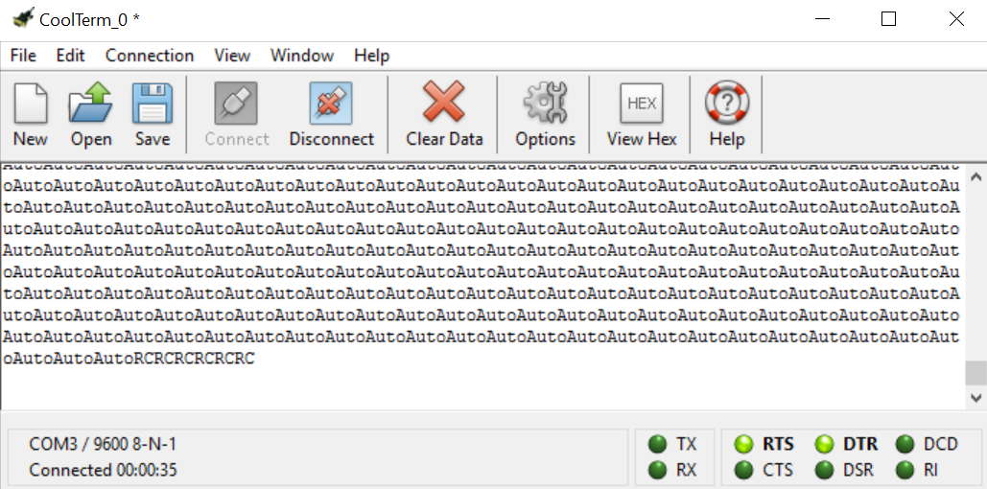

  - Conclusions:
    - Criteria to Pass: When in RC mode and commands are being sent Coolterm will be sending the word “RC”, when in autonomous mode it will print “Auto”.
As seen in the image above, “Auto” is printed when autonomous mode was selected for the control mode. “RC” is printed when remote control mode is selected and commands are being sent from the phone.

- Requirement: The 3Dot board should send custom telemetry to the Arxterra Control Panel via Bluetooth.
  - Method:
    - Inspection
  - Materials:
    - Goliath Code name “Goliath_Code”
    - Computer with Arduino IDE
  - Procedures:
    - Open the file containing Goliath’s Code
    - Examine the code to see if any custom telemetry is being sent.
  - Conclusions:
    - Criteria to Pass: Custom telemetry is being sent to the Arxterra Control Panel.
Goliath has no custom telemetry coding therefore it fails this inspection.

- Requirement: Goliath shall use five SMD LEDs to indicate the location of the Biped. (Based on the program objective [6])

Table 8
LED Pattern (5 LEDs) | Meaning of Pattern
2 left LEDs on | Biped located on left side of Goliath
2 right LEDs on | Biped located on right side of Goliath
3 middle LEDs on | Biped located in front of Goliath
LEDs Brightness | Meaning of Brightness
Blue | Biped is greater than 70 cm from Goliath
Green | Biped is 50 to 70 cm from Goliath
Red | Biped is less than 50 cm from Goliath

Table 9
Left Sensor Reading vs Right Sensor Reading | Meaning of Pattern
Left < Right | Biped located on left side of Goliath
Left > Right | Biped located on right side of Goliath
Left = Right | Biped located in front of Goliath

  - Method:
    - Test
  - Materials:
    - Biped Model
    - Computer with Arduino IDE
    - USB to micro USB cable
    - Goliath
  - Procedures:
    - Connect Goliath to Arduino IDE using the USB cable
    - Using Arduino IDE serial print, print the readings of the sensors.
    - While Goliath is stationary move the Biped 20 inches in front of the sensors.
    - Compare the location of Biped to Goliath and see if it matched the LEDs to the table 8 above.
    - Compare the readings of the sensors and actually locations of Biped.
    - Move Biped to a variety of location and repeat step 4 - 5.

Reading from when Biped on the Right:

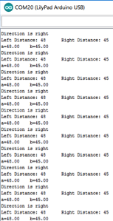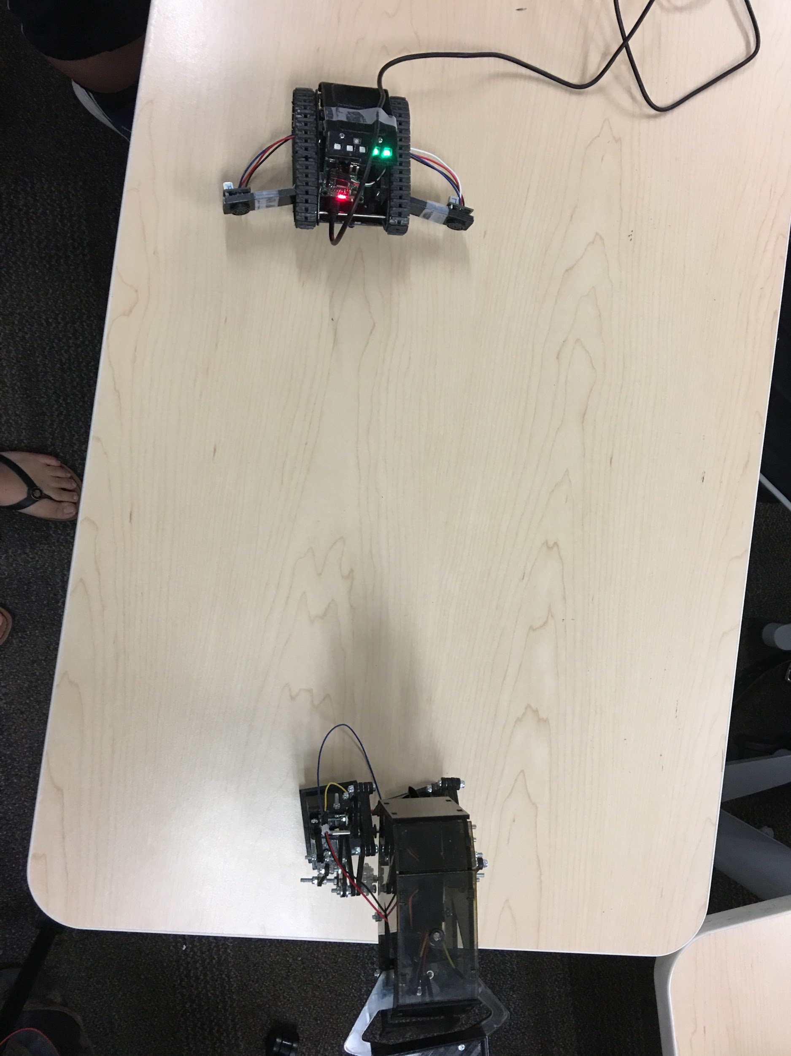
Reading from when Biped on the Left:
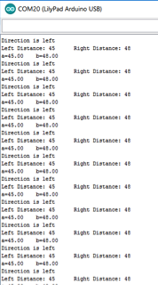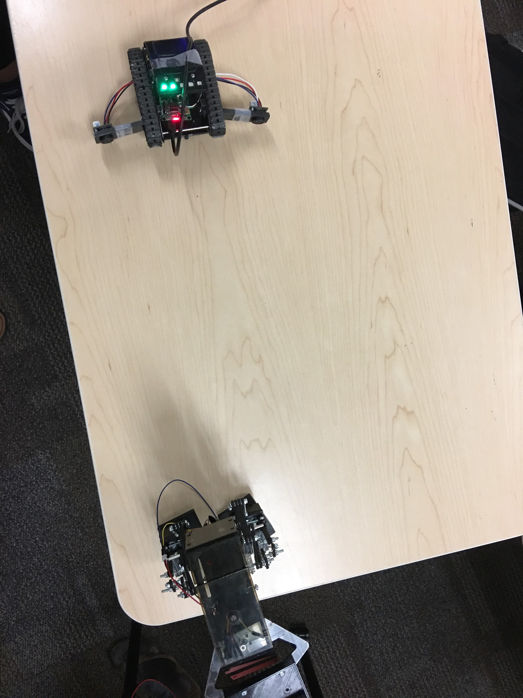
Reading from when Biped in Front:
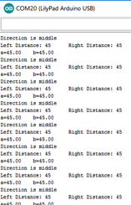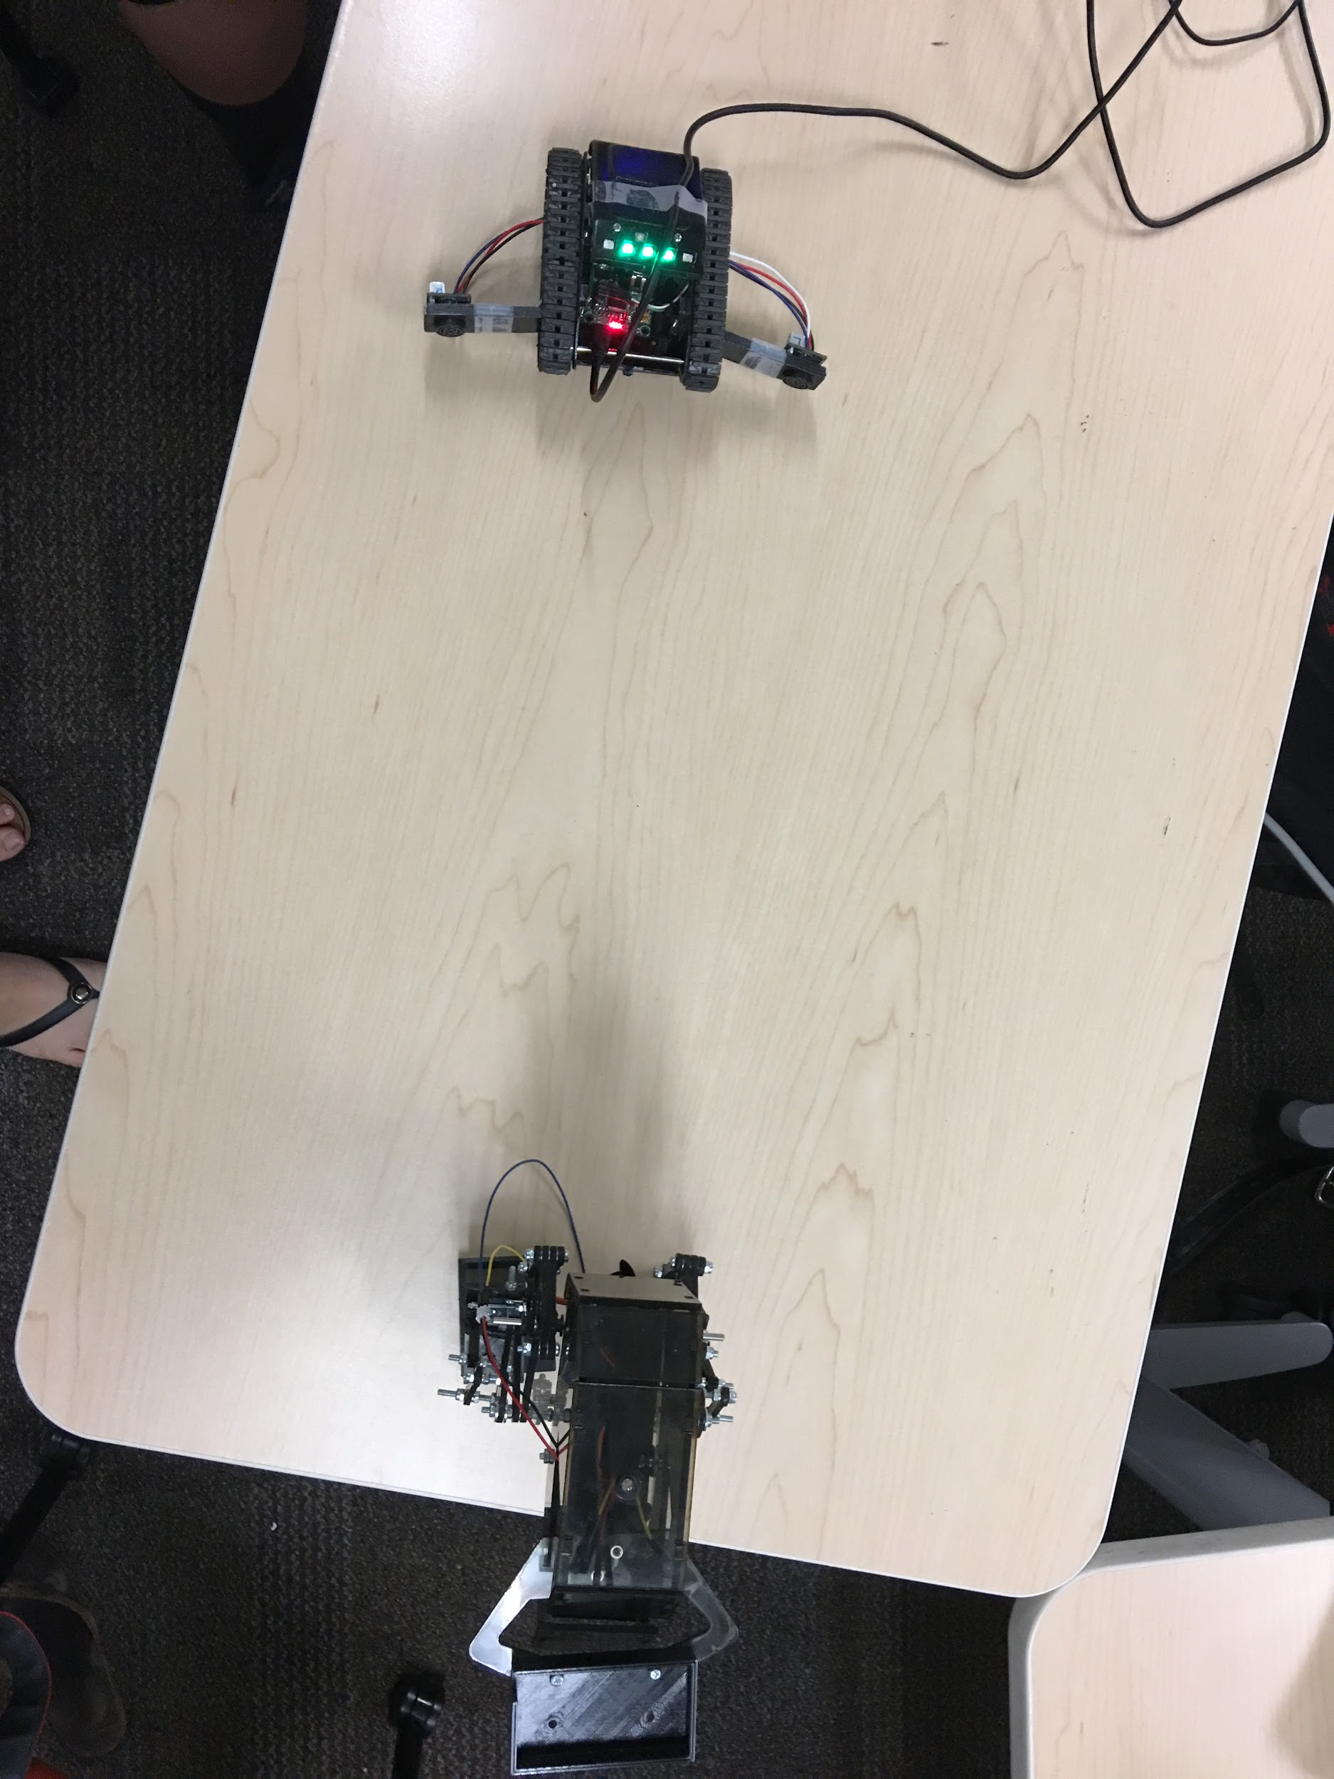
  - Conclusion:
    - Criteria to Pass: The reading, LEDs, and location of the Biped match up from the test.
Goliath’s code and LEDs print and display the correct location of Biped as seen from the images of serial print and the pictures.

- Requirement: Goliath shall play sound during the beginning of the game.
  - Method:
    - Test
  - Materials:
    - Decibel Meter
    - Speaker
  - Procedures:
    - Play the song and watch the decibel meter to see that is stays within 20 to 70dB.
 | dB reading
Trial 1 | 66.7
Trial 2 | 65.7
Trial 3 | 64.8

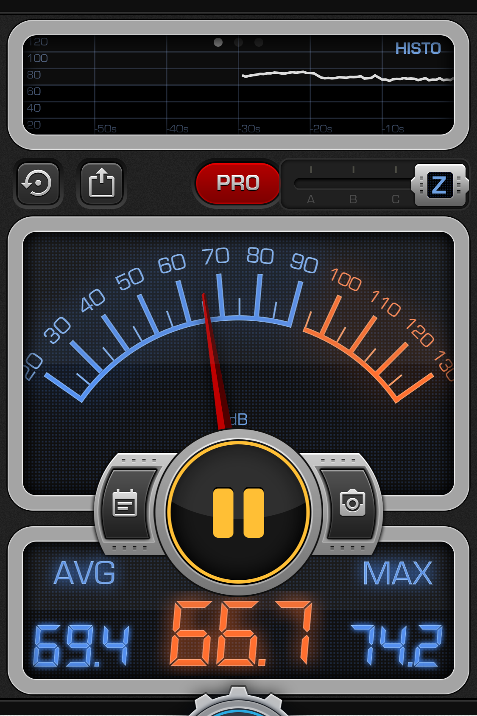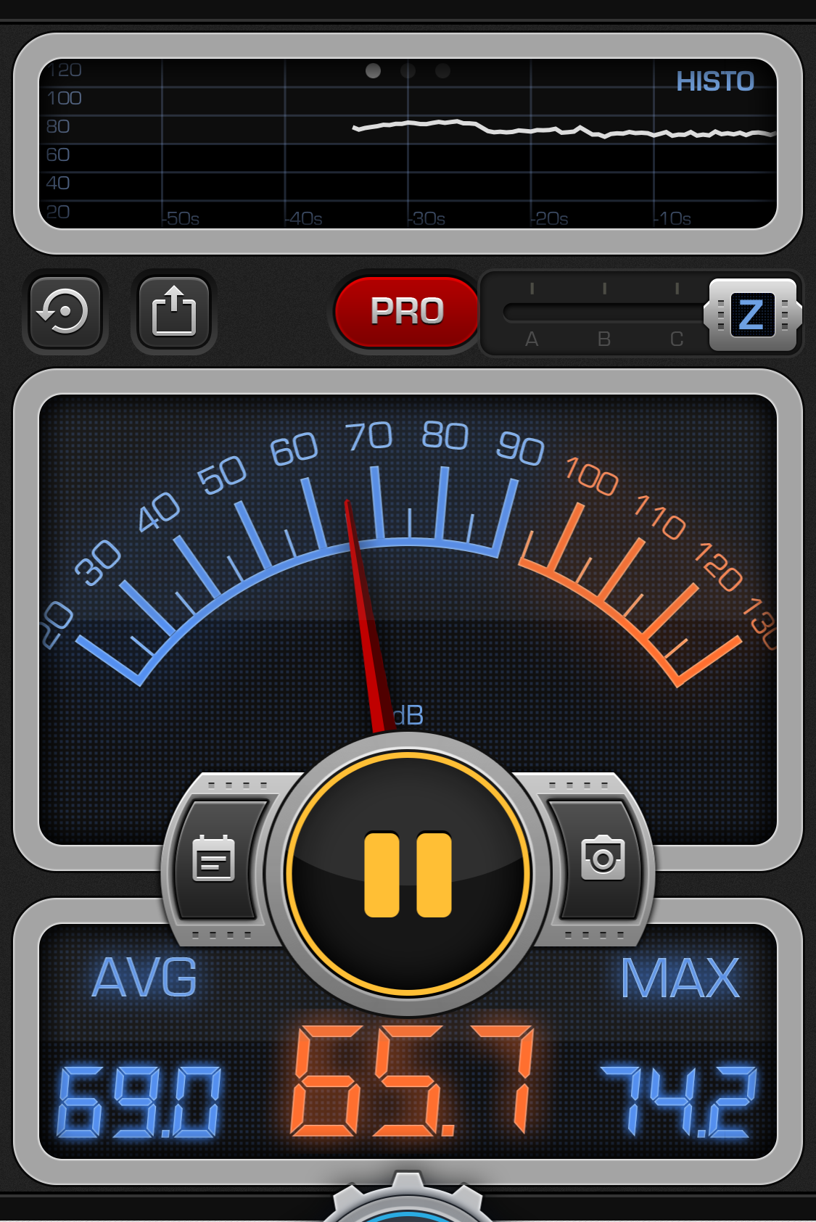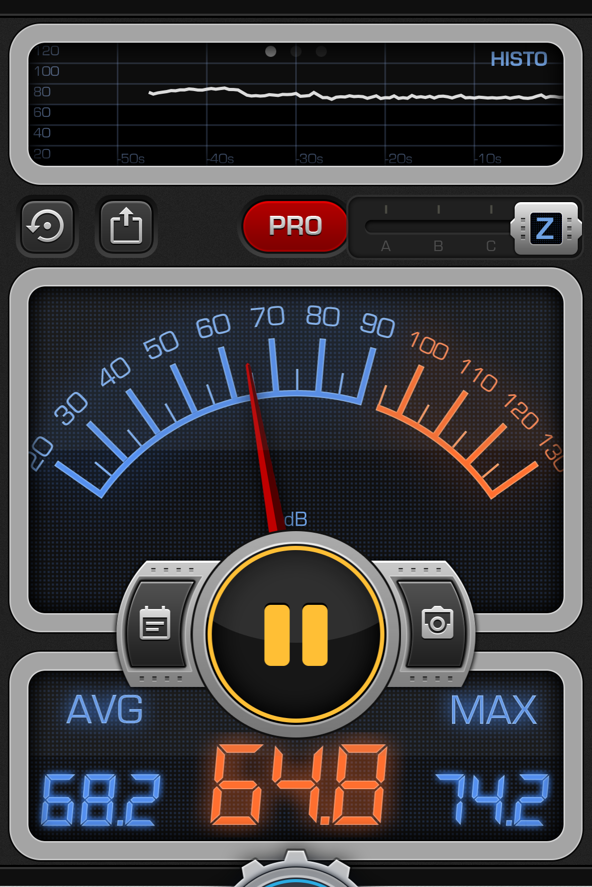
  - Conclusion:
    - Criteria to Pass: The decibel reading should be in the range of 20 - 70dB[2]
Looking at the three trials we can calculate that the average dB reading is 65.733 dB. Each trial is below 70 dB and the average is below 70 dB. Therefore our speakers passed the requirement.

- Requirement: The Goliath shall be a scale model of the Goliath 302 tank. (Based on the customer objective [2])
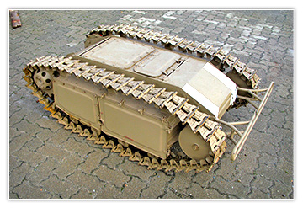
Figure 2 (Back)
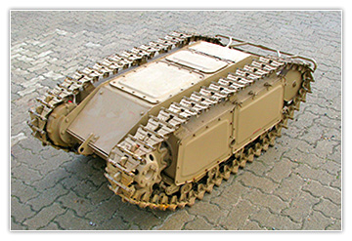

  - Materials
    - Ruler
  - Activity
    - Examine top panel for door designs
    - Examine side panels for same indentation
    - Examine Goliath back bar
    - Examine wheels
    - Examine hinge on Goliath
    - Examine tracks
    - Measure the dimension to see if it within 10% the 1 : 0.566 : 0.373 ratio (4.39 x 2.48 x 1.63) (length x width x height)

Goliath Model: 8.7 x 3.7 x 2.7

Calculations:
$\frac{8.7}{8.7}:\frac{3.7}{8.7}:\frac{2.7}{8.7}$ = 1 : 0.425 : 0.310

%Error = $\frac{|Expected * Experimental|}{|Expected|}*100$
$\%Error for Width=\frac{|0.566 * 0.425|}{|0.566|}*100=92.49\%$
$\%Error for Height=\frac{|0.373 * 0.310|}{|0.373|}*100=16.89\%$
  - Conclusion
    - Criteria to Pass: Ratio of the 3D printed model are within 20% of 1 : 0.566 : 0.373 and Goliath has details similar to the Goliath 302.
Goliath failed at the scale test because it had a 92% error for the ratio of the width. Examining the our calculation and print details we can see Goliath passes 3 out of 4 of the activities which means it passes by 75%.

- Goliath shall have a custom PCB.
  - Method:
    - Inspection
  - Materials:
    - Goliath
  - Procedures:
    - Goliath custom PCB is supposed to display the location of the Biped and play sound (optional). If Goliath can do either of those that mean our PCB is functional.
  - Conclusions:
    - Criteria to Pass: Test for L1-8 or L1-9 passed.
Goliath pass both test for producing a sound and being able to display the location of Biped. With both test passed we can say that our custom PCB is functional and present in our product. In conclusion, Goliath has a custom PCB.

- Requirement: Goliath will use the 3Dot board.
  - Method:
    - Inspection
  - Materials:
    - Goliath
    - Arxterra Control Panel
    - Phone
    - Arxterra Application
  - Procedures:
    - Connect all parts necessary in order to run the Goliath.
    - Use the Arxterra application to connect with the 3Dot board via Bluetooth.
    - Use the Arxterra application to connect to the Arxterra Control Panel.
    - Use the RC mode to send commands to Goliath.
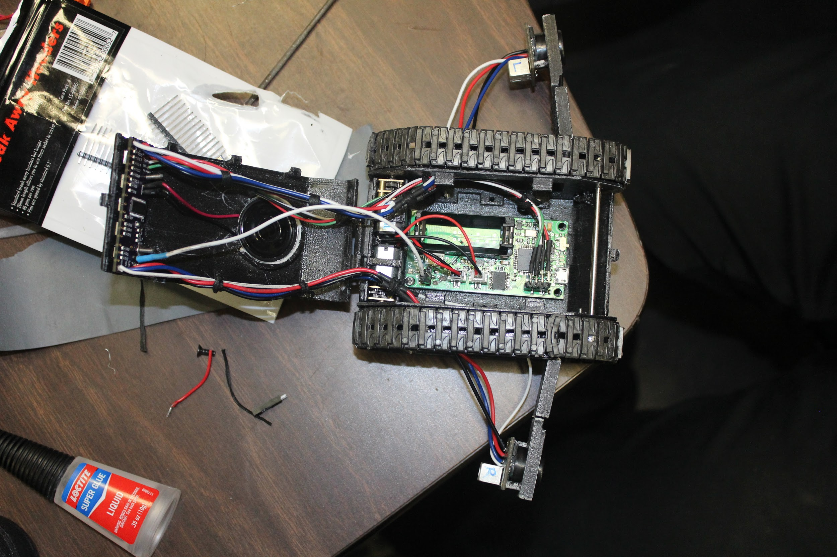
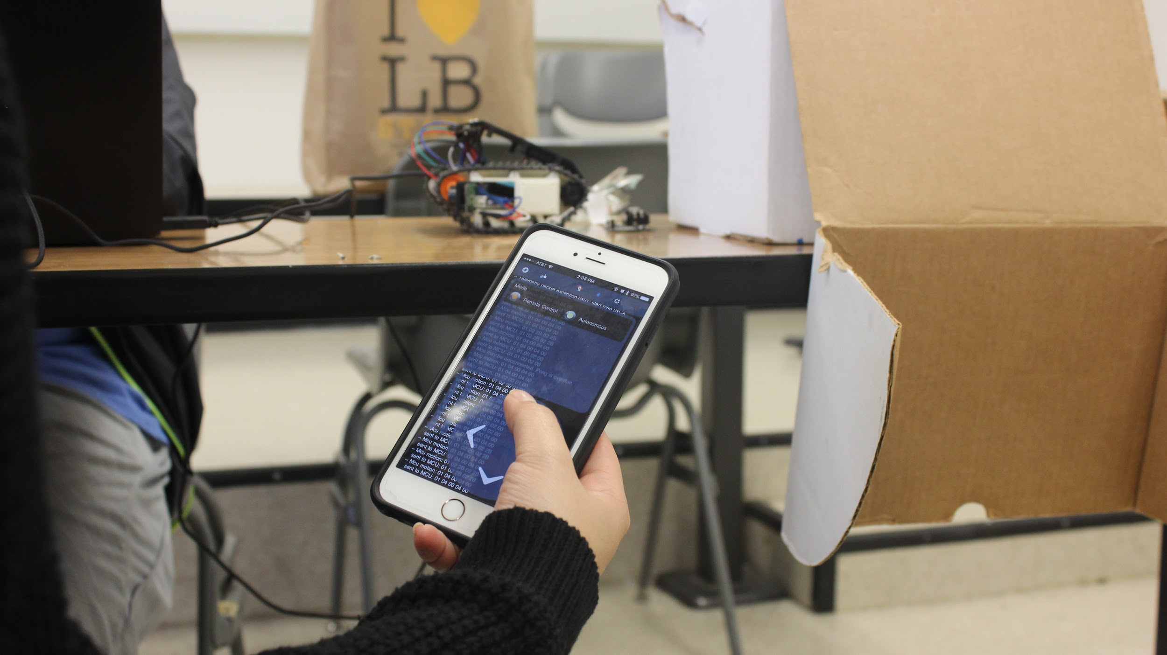
  - Conclusions:
    - Criteria to Pass: Goliath is powered by 3Dot and using it to communicate with Arxterra in order to receive RC custom commands.
The Arxterra Control Panel connected to the phone, which is connected to the 3Dot board, which powered the motors and had the code to run RC mode. When the desired button was pushed in drove in the same direction.

- Requirement: Goliath will use the 3Dot board library.
  - Method:
    - Inspection
  - Materials:
    - Computer
    - Code
  - Procedures:
    - Open the Goliath code.
    - Examin come to see if it is using any of the commands or definitions that are built into the 3Dot library.

MOVE Command Code:
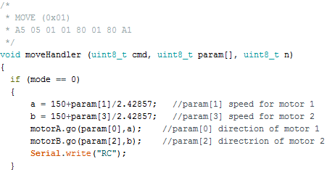
Battery Packets:

  - Conclusions:
    - Criteria to Pass: When in RC mode Goliath is moving according to user inputs, when in autonomous mode user is moving by itself.
As seen in the code above, Goliath is using the build-in MOVE command to remote control the Goliath during RC mode. In addition, Goliath is sending the battery level of the 3Dot board for telemetry which is using packets that were predefined in the 3Dot library.

L1 - S. Requirements:
- Goliath shall be able to travel on flat surfaces.
- Goliath shall traverse the cardboard and linoleum surfaces of the 12ft and 15ft course.
- Goliath shall be able to travel on uneven surfaces up to 0.5mm.
- Method:
  - Demonstration
- Materials:
  - Cardboard
  - Goliath
  - Phone
  - Arxterra Application
- Procedures:
  - Turn on the Arxterra Application and connect it the 3Dot that is on board the Goliath.
  - Controlling the Goliath in RC mode move around the area to complete all the task in the table below.

Task | Pass/Fail
Travel on flat surface | Pass
Trave on cardboard and linoleum | Pass
Travel on uneven surfaces up to 0.5mm | Pass

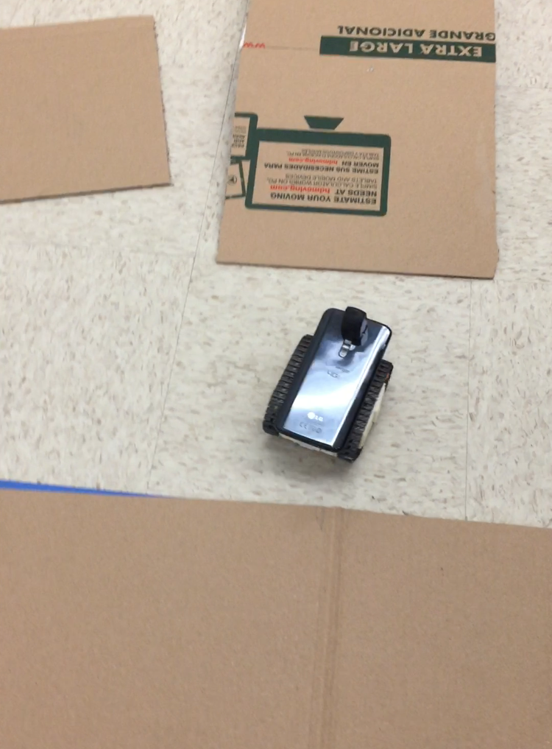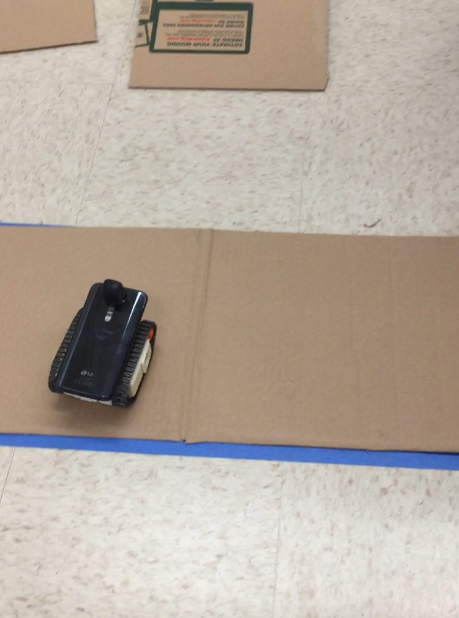

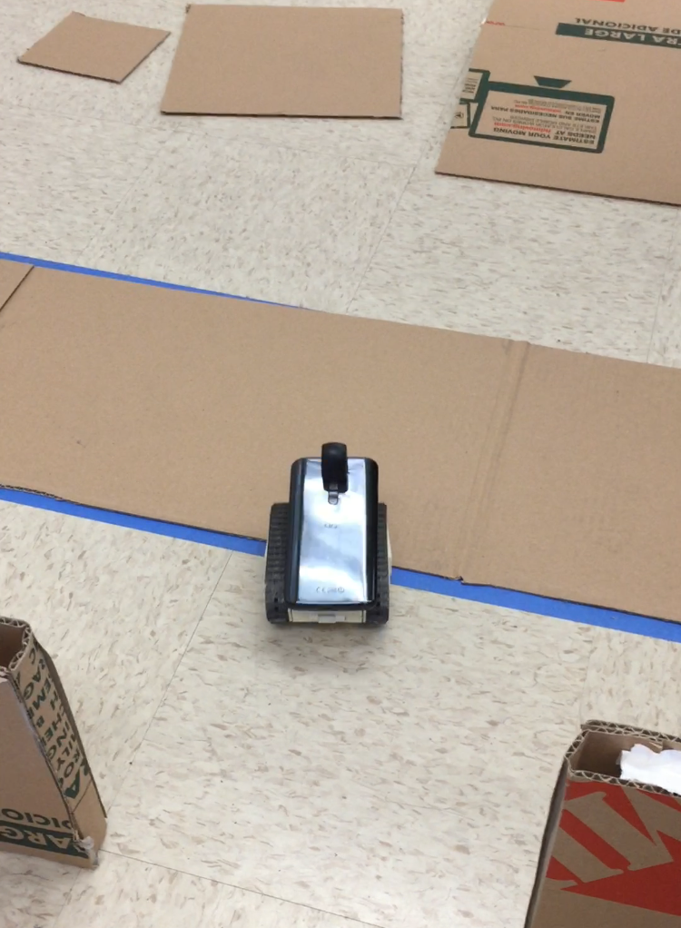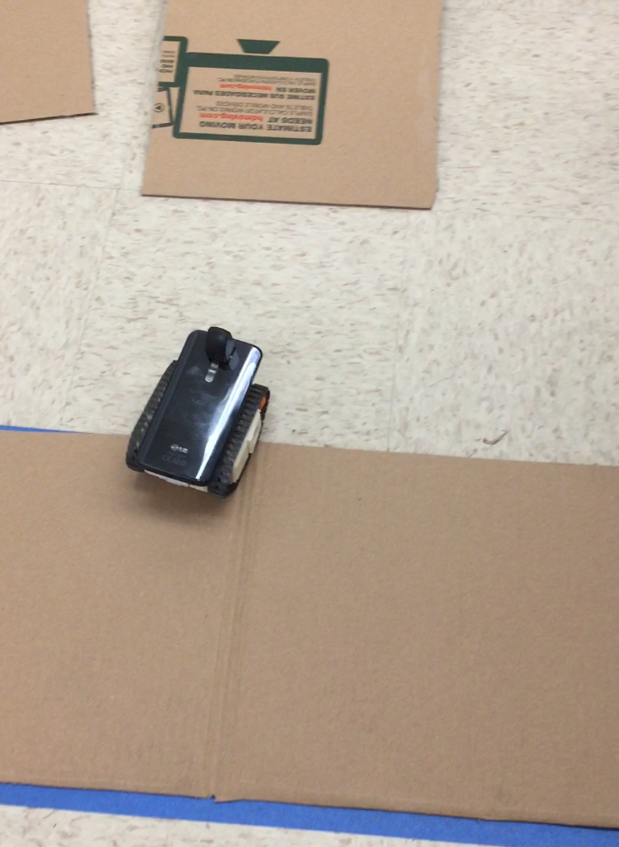

- Conclusion:
  - Criteria to Pass: Goliath pass all of the task in the table above.
When we were driving Goliath in RC mode we were able to travel on flat surfaces, uneven surfaces, cardboard and linoleum. With everything on the table as a pass we passed the entire test.

L1 - S3. Requirement: To drive the Goliath up the 6 degree incline, the motor shall provide a minimum torque of 0.0249 Nm. [7]
  - Method:
    - Test
  - Materials:
    - Scale
    - Goliath
    - String
    - Ruler
    - Motor
    - Plastic Water Bottle (Empty)
    - Water
  - Procedures:
    - Measure the diameter of the the shaft and divided it by 2 to get the radius.
    - Using the equation T = mass * radius of winding * 9.8. We can solve for the mass we need for testing since we know the needed torque is 0.0249 Nm and the radius of the shaft.
    - Pour enough water into the water bottle so that it weighs the same as Goliath
    - Tie one end of the string to the shaft of the motor and the other to the water bottle.
    - Place the motor at the edge of the table and let the string and object hang off the side of the table
    - Hold the motor down and power it on so that the shaft turns and winds up the string
    - Continue to the the string wind up until the motor stops
    - Turn off the motor and hold the winded up so it does not unwind.
    - If the motor winds up all the way get an object that weighs more
    - Calculate the torque using $Torque = Mass*Radius*9.8$
    - Repeat with other motor
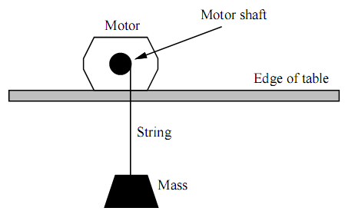
Figure 1: Motor set up, [1]
Calculations:
$Torque = Mass*Radius$
$0.02 = Mass*0.003$
$Mass =$0.666 kg
Motor 1
Mass of Object: 633 g
Radius of Winding: 0.005 m
$Torque = 633*0.005*9.8$
Torque: 0.03107 Nm
Motor 2
Mass of Object: 646 g
Radius of Winding: 0.004 m
$Torque = 646*0.004*9.8$
Torque: 0.025 Nm
  - Conclusion:
    - Criteria to Pass: Both motors will provide a minimum torque of 0.0249 Nm.
Motor one produces a torque of 0.03107 Nm while motor two produces a torque of 0.025 Nm. Therefore, both motors produce the minimum amount of of torque required.

- Requirement: Goliath should use triangulation to find the location of the Biped.
  - Method:
    - Inspection
  - Materials:
    - Goliath Autonomous Code
  - Procedures:
    - Inspecting Goliath Autonomous Code check to see if it is using law of cos and law of sine to calculate angles and lengths of sides. In addition, the input of the sensors should be used in these calculations

  - Conclusions:
    - Criteria to Pass: Goliath correctly calculated the angle of Biped based off of the sensor readings.
Goliath is using the law of sine and cos with information given by the sensors and the know lenght of how far apart the sensors are.

- Requirement: Goliath shall be Biped’s vision during the game shall be provided by the camera and periscope on the Goliath (Based on the phone specs and Arxterra Control Panel [3] [4])
  - Method:
    - Demonstration
  - Materials:
    - Goliath
    - Phone with Arxterra
    - Periscope
    - Computer logged into Arxterra Control Panel
  - Procedures:
    - Using the instructions stated this blog post connect the Arxterra Application and Arxterra Control Panel.
http://arxterra.com/arxterra-control-panel/
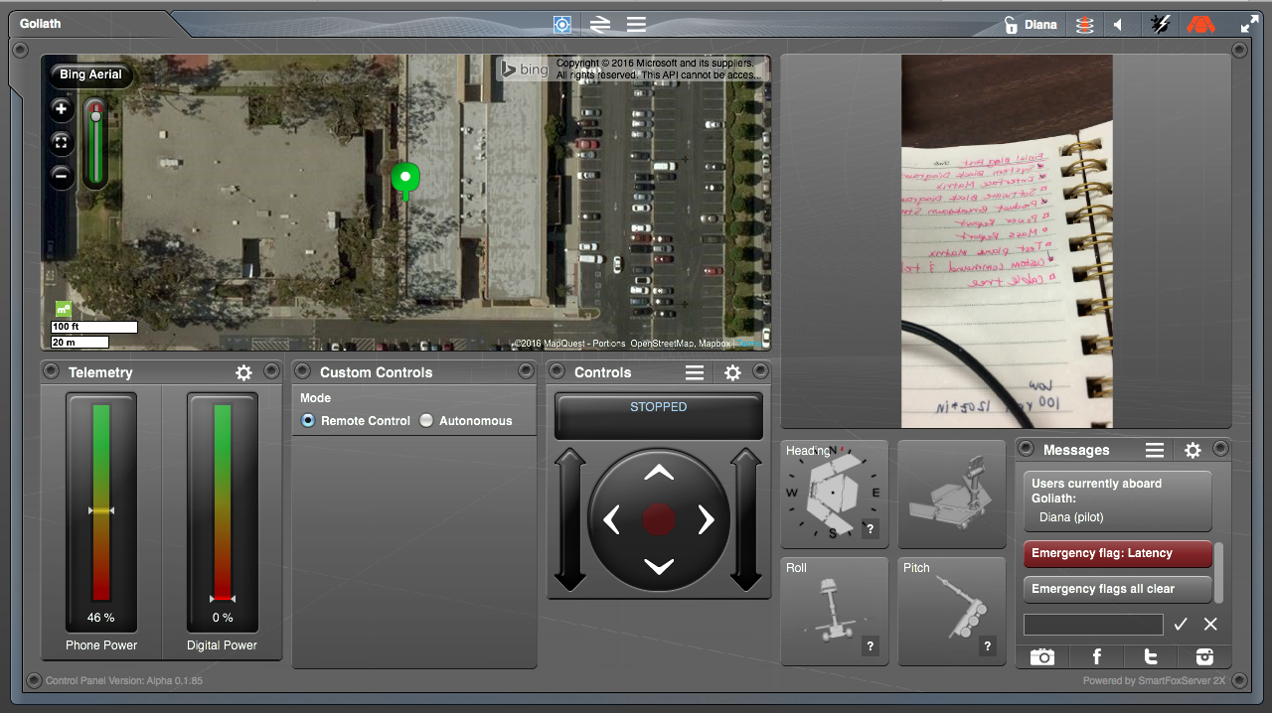

  - Conclusions:
    - Criteria to Pass: Arxterra is broadcasting a live camera feed from the phone.
Using an iPhone, Arxterra application, and Arxterra control panel we were successfully able to broadcast a live feed from the Iphone camera. As demonstrated in the picture above you can see we are able to pass.

- Requirement: Goliath will not surpass a mass of 2768.8 g.
  - Method:
    - Test
  - Materials:
    - Goliath Model with all its internal components
    - Scale
  - Procedures:
    - Place on scale and measure the weight

Goliath Mass: 169 g
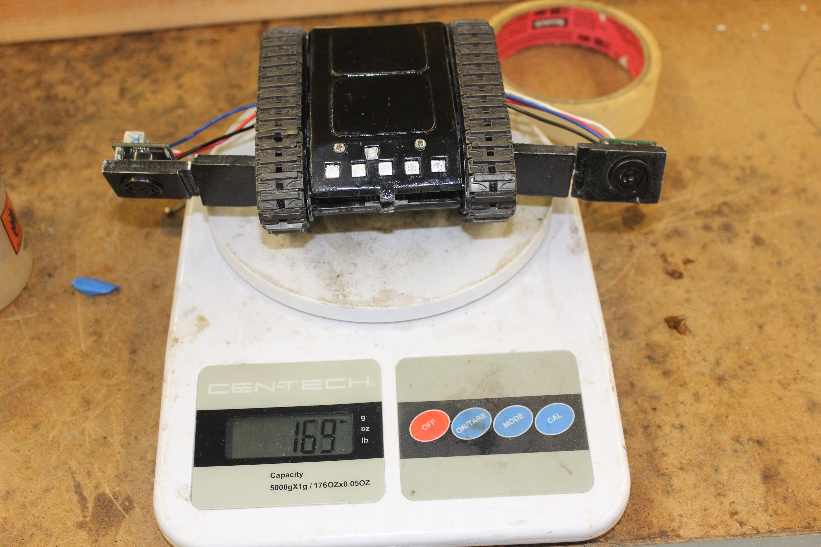
  - Conclusions:
    - Criteria to Pass: Goliath must weight less than 2768.8 g.
Goliath’s mass is 169 g with all its internal components. This is far below the the weight to pass the requirement and therefore we can conclude it passes.

