Reimbursement Request for 3D SMD robot project
Henry Nguyen
10731 Funnel Circle
Westminster, CA 92683
Phone: (714) 555-4317
E-mail: HenryVanNguyen100@gmail.com

October 31, 2016

To Whom it May Concern,

In support of EE400D “Electrical Engineering Design Seminar and Project”, the following individuals purchased parts to help build the 3D SMD robot project. Following is a breakdown of the parts purchased and requested reimbursement.
Receipt | Vendor | Item | Unit Price (including shipping) | Quantity EE Dept. /Total | EE Dept. Extended Cost | Bao Loc Doan Purchase | Henry Nguyen Purchase | Nasser Alsharafi Purchase
1 | Ebay | Makeblock XY Plotter Robot Kit | $267.66 | 1 | $267.66 | $267.66 | - | -
2 | MakeBlock | 42BYG Geared Stepper Motor  6P6C RJ25 cable – 50cm(Pair)  Linear Motion Slide Unit 8 mm (Pair)  Me Micro Switch B  Me Stepper Motor Driver | $209.71 | 1 | $209.71 | $209.71 | - | -
3 | MakeBlock | 6P6C RJ25 cable – 50cm(Pair)  Me RJ25 Adapter  Me UNO Shield  Thread Drive Pack V2.0 - Blue | $68.55 | 1 | $68.55 | $68.55 | - | -
4 | Pololo | FEETECH FS90R Micro Continuous Rotation Servo | $5.69 | 4 | $34.15 | $34.15 | - | -
5 | Robotdigg | High-Frequency Solenoid Valve 24VDC  Nema8 Hollow Shaft Stepper Motor  Nozzle w/ Adapter to 5 mm Hollow Shaft Stepper | $84.00 | 1 | $84.00 | $84.00 | - | -
6 | Amazon | Tetra 77885 Whisper Air Pump – 100 gal | $19.00 | 1 | $19.00 | - | $19.00 | -
7 | Amazon | Python Airline Tubing for Aquarium, 25-Feet  Anderson Metals 57001 Brass Hose Fitting, Adapter, 1/4" Barb x 1/4" NPT Male Pipe | $8.18 | 1 | $8.18 | - | $8.18 | -
8 | Ebay | Reel Feeders | $31.95 | 1 | $31.95 | - | - | $31.95
9 | Amazon | Flexible Coupling 5mm to 5mm  XL Type 40 Teeth Aluminum Timing Pulley  4mm to 8mm Helical Shaft Coupler | $33.74 | 1 | $33.74 | $33.74 | - | -
 |  |  |  | Total: | $756.94 | $697.81 | $27.18 | $31.95

Our allotted project budget was $775. Total reimbursement amount requested is $756.94. $697.81 will be reimbursed to Bao Loc Doan. $27.18 will be reimbursed to Henry Nguyen. $31.95 will be reimbursed to Nasser Alsharafi.
This amount includes shipping. The Unit Price (including shipping) column in the above table was calculated by dividing the shipped cost by the total number or items purchased on that receipt. Copies of all receipts are enclosed.
Total funds remaining for our project are $18.06.
All parts were provided to the Instructor - Gary Hill, and will be located in the cabinets in ECS-316 at the end of the semester.
Instructor Approval:

Gary Hill

Total Amount Reimbursement: $697.81
Bao Loc Doan
3456 Walter Street
Westminster, CA 92683
Phone: (714) 555-3491
E-mail: LocDoan100@gmail.com
CSULB Student ID: 019607935
Total Amount Reimbursement: $27.18
Henry Nguyen
10731 Funnel Circle
Westminster, CA 92683
Phone: (714) 555-4317
E-mail: HenryVanNguyen100@gmail.com
CSULB Student ID: 019847075
Total Amount Reimbursement: $31.95
Nasser Alsharafi
1215 S Falcon Circle
Anaheim, CA 92805
Phone: (956) 555-3939
E-mail: n100@gmail.com
CSULB Student ID: 019865220
Receipt 1:
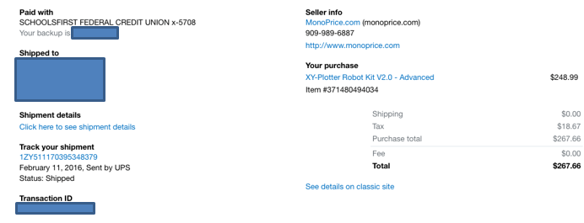
Receipt 2:
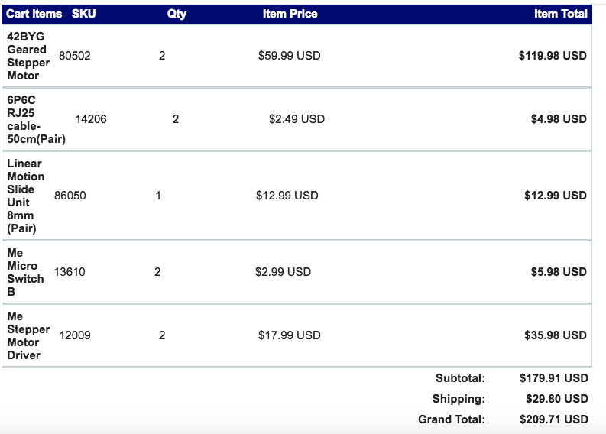

Receipt 3:
